PATHWAY-BASED APPROACH TO MODELING CAUSALITY AND

DETECTING GLIOBLASTOMA

Bernardo Jordan

School of Computing and Information Sciences

Florida International University

2020

Advisory Committee

Dr. Gabriel Odom, Committee Member 1

Dr. Nan Hu, Committee Member 2

Dr. Giri Narasimhan, Chair

TABLE OF CONTENTS

Page

Chapter 1: Abstract 1

Chapter 2: Review of Literature Review 2

Brain Cancer and Glioblastoma 2

Treatment 3

Diagnosis 6

Chapter 3: Methodology 8

Overview 8

Dataset 8

Data Wrangling 9

Eigengene Creation 9

PathwayPCA 10

Network Creation 11

Chapter 4: Results 12

Performance Evaluation 12

Analyzing the Network 14

Chapter 5: Discussion 17

Significance of Pathway Analysis 17

Analysis of Models 17

Chapter 6: Conclusion 19

References 20

Figures

1 Microscope picture of an Astrocyte 2

2 Overview of Methodology 8

3 AES-PCA Pathway Significance 11

4 Glioblastoma Node in the Pathway Bayesian Network 15

5 Glioblastoma Node in the Gene Bayesian Network 16

Tables

1 10 – Fold Cross Validation (Pathway Approach) 12

2 10-Fold Cross Validation (Pathway Approach vs Gene Approach) 13

3 Testing Set Results 13

4 Repeating Pathways in the 10-Fold Cross Validation 14

5 Literature Analysis of Nodes Interacting with Glioblastoma 16

CHAPTER 1: ABSTRACT

Glioblastoma is a highly aggressive form of primary brain tumor that is not fully understood. Even with our current advancements in treatments, the survival rate of patients is very poor.[1] Therefore, research is being done in detecting and understanding low grade glioblastoma in hopes of providing better treatment. In this capstone, I present a new method for detecting low grade glioblastoma while at the same time providing biological relevance and understanding of the underlying casual relationships in Glioblastoma. This will allow doctors and clinicians to potentially provide earlier and more effective treatment.

CHAPTER 2: LITERATURE REVIEW

**BRAIN CANCER AND GLIOBLASTOMA**

In the United States, the second leading cause of mortality is cancer.[1] Approximately 21% of annual deaths are cancer related.[1] Over the last few years, interest in cancer research has exploded.[2] Brain cancer in particular has seen substantial growth.

Currently, about 700,000 Americans are living with some form of brain tumor.[1] 70% of which are Benign and 30% are Malignant.[1] Benign tumors are small, slow-growing, non-invasive tumors that can be removed with a degree of ease.[3] On the other hand, Malignant tumors are large, fast-growing tumors that invade and destroy surrounding tissue.[3] Malignant tumors are difficult to remove and prone to recurrence[3] It is estimated that about 1.4% of all new cancer cases are primary malignant brain tumors.[1] Of these new malignant brain tumors, about 45% of those are a type called Glioblastoma.[1]

Glioblastoma is a deadly type of brain cancer. It has four grades, I-IV, with I being the least deadly and IV being the deadliest. The origin cell from which Glioblastoma forms from is called an Astrocyte.[1] These astrocytes perform various functions, some of which include regulating ionic concentration in the brain, excreting waste, and repairing neuronal tissue.[4] Glioblastoma is a highly invasive and aggressive tumor that metastasizes quickly.[1][5] This causes early death in patients unfortunate enough to develop Glioblastoma. The median survival time for a patient diagnosed with Glioblastoma is only nine months.[5] If the patient undergoes treatment, this survival time rises to 15-16 months.[5] However, even with advancements in medical technology and new treatments, only 5% of patients survive past five years.[5] While the exact reason for why Glioblastoma and other brain cancers form is unknown, two main risks factors have been identified.[6]

Figure 1: Microscope picture of an Astrocyte.[31]

The first main risk factor is age.[6][7] Research has shown that as a person ages, the risk of developing Glioblastoma increases.[7] The median age of diagnosis is 64 years of age and peaks at 75-84 years of age.[7] While uncommon in children, Glioblastoma does comprise approximately 3% of all brain and central nervous system tumors in patients that are 0-19 years of age.[7]

The second main risk factor that has been identified to increase the risk of developing Glioblastoma is exposure to ionizing radiation.[6][8] Ionizing radiation is a type of radiation in which the comprising wavelengths carry enough energy to damage the DNA of cells and cause it to die or mutate.[8] Exposure to high doses of ionizing radiation can cause sickness and cancer in patients.[8] The most common sources of ionizing radiation are X-rays, nuclear powerplant and weapons, and radiation therapy.[8]

**TREATMENT**

One difficult aspect of treating Glioblastoma is that treatment options are limited due to the sensitive nature of the brain. Unlike other cancers, even a small mistake treating brain cancer can lead to permanent damage or even death. As a result, there are three common types of treatments used for treating Glioblastoma.[9]

The first type of treatment that exists to treat Glioblastoma is to surgically remove the cancer.[9] Surgeons make a small incision into the skull and attempts to remove as much of the tumor as possible.[9] However, full removal of the cancerous tumor can be very difficult.[9] Due to the functions that astrocytes need to perform, astrocytes have developed a unique shape.[4] They possess tentacle-like appendages that radiate outward from the center body.[4] This gives astrocytes their unique star-shape appearance and allows a single astrocyte to interact with many different cells in the brain.[4] One big downside of this unique shape is that the cell is not centrally localized. As a result, it is very difficult to fully remove the cancerous tumor.[9] Leaving any part of the cancerous tumor in the brain can cause reoccurrence. In addition, there are many risks involved in performing brain surgery.[9] Bleeding and infection are two big concerns when performing brain surgery since these can lead to permanent brain damage.[9] Location of the tumor is also a big concern when performing brain surgery due to the fragility of the brain.[9] A small mistake by the surgeon can leave a patient with a lifelong effect such as blindness. As a result, surgery is often supplemented with other treatments in an attempt to fully kill the cancerous cells.[9]

The second type of treatment used to treat Glioblastoma is radiation therapy.[9] Radiation therapy is performed by targeting the cancerous cells with a high energy beam in hopes of killing the cells.[9] While this treatment is effective, it also has risks.[9] Brain swelling is one common side effect.[9] This in-turn can cause the patient to experience headaches, seizures, hearing loss, trouble with memory, and many other unpleasant side effects.[9] While low, radiation therapy can cause a secondary tumor to form.[9] As mentioned before, one risk factor for developing Glioblastoma is ionizing radiation.[6][8] Since high energy beams are being fired directly to the brain, it is possible that these beams cause healthy cells in the brain to mutate and become cancerous.[9]

The last type of treatment commonly used to treat Glioblastoma is chemotherapy.[9] Chemotherapy involves the use of drugs to kill the cancerous cells.[9] These drugs can be taken as a pill or injected intravenously. The most commonly used chemotherapy drug for glioblastoma is temozolomide.[9][10] Temozolomide works by targeting cancerous cells that are rapidly dividing and damaging their DNA.[10] This stops the cancerous cells from further proliferating and growing, which in turn causes the cells to die.[10] While this drug can help in treating Glioblastoma, it has side effects. Since the drug cannot differentiate between cells that are rapidly dividing due to cancerous mutations and healthy cells that are rapidly dividing due to normal biological functions, such as blood cells, many patients experience side effects.[10] Common side effects include hair loss, brain swelling, seizures, and low blood counts.[10] Low blood counts are particularly dangerous since it increases a patient’s risk of developing infections, which can then lead to further complications and even death.[10]

Since not one of these treatments is 100% effective in removing the brain tumor, multiple treatments are used in tandem to treat Glioblastoma in what many have phrased the “Slash, Burn, Poison” approach.[11] Even with these treatments, only about 5% of patients survive past 5 years.[11] As a result, scientists and doctors are looking for new ways to treat Glioblastoma.[11]

One new treatment option that doctors and scientists are investigating is immunotherapy.[11] Immunotherapy involves using drugs and treatments to help a patient’s immune system identify and destroy cancerous cells.[11] While the idea sounds good in theory, immunotherapy has shown mixed results and yielded little progress.[11] As a result, only a small handful of gene therapies for certain cancers are FDA approved.[11] It is not approved by the FDA to be used to treat Glioblastoma and is only in the clinical trial phase.[11] More research needs to be done in immunotherapy before it can be considered in treating a complicated cancer like Glioblastoma.[11]

**DIAGNOSIS**

Before treatment can even be administered, a patient must first be diagnosed with Glioblastoma or a brain tumor. The process for which this diagnosis occurs is simple yet time consuming.

The first step in diagnosis is a physician notices that something is out of the ordinary. Usually this is noticed when the doctor performs a neurological exam.[9] In this exam, the doctor checks a patient’s vision, hearing, coordination, strength, and reflexes.[9] If a doctor suspects that the root cause of a problem in one of these areas is brain related, the doctor will then send the patient to get an imaging test performed.[9]

Imaging tests attempt to create detailed images for a part of the body.[9] When diagnosing brain cancer, the most commonly used test is a Magnetic Resonance Imaging (MRI) test.[9] An MRI works by using powerful magnets to produce a strong magnetic field.[12] When inside of this magnetic field, protons in the body align with the magnetic field.[12] Radio frequencies are then pulsed into the patient which causes the protons to spin out of equilibrium.[12] The radio frequency currents are then turned off and the protons realign with the magnetic field.[12] In doing so, energy is released that is then picked up by a sensor and used to create the image based on how fast the energy is released.[12] Once the image is created, a doctor will look at the image and determine if there are any abnormalities.

If abnormalities are detected, the doctor will then test for other types of cancer.[9] The reasoning behind this is that since brain tumors and Glioblastoma are actually rare, there is a higher probability that the abnormality found may be a result of a different type of cancer located somewhere else in the body.[9] Since malignant tumors tend to metastasize, it is possible that the abnormality found in the brain originated elsewhere.[9]

Once it is determined that the tumor did not originate from another part of the body, a biopsy is performed.[9] In a biopsy, a surgeon makes a small incision in the skull and removes a small piece of the tumor.[9] The sample is then placed under a microscope to determine if the brain tumor found is cancerous and its progression.[9]

While this conventional process works in diagnosing Glioblastoma and other brain cancers, it is not very efficient. MRIs and other imaging scans sometimes have trouble accurately visualizing the tumor.[12] This can be a result of inaccuracies in the instrument, patient moving during the exam, location of the tumor, etc.[12] Biopsies, while being the definitive way of determining if a tumor is cancerous, are very invasive.[9] Biopsies can lead to bleeding and infection.[9] The location of the tumor may cause issues during the procedure. However, the greatest downside to this diagnostic process is the time delay associated from when the doctor initially suspects something is wrong to conformation of the cancer. Given that the median survival time for a patient diagnosis with Glioblastoma is only nine months, by the time the cancer is fully confirmed, the cancer may have progressed further along and metastasized, which in turn decreases the amount of time the patient has left to live.

Due to this time delay that occurs in the traditional diagnosis path, researchers and doctors are investigating new mechanisms to be able to detect Glioblastoma in a non-invasive way to provide earlier treatment. As a result, recent research has looked for a way to detect glioblastoma from other bodily fluids, such as blood, in hopes of being able to detect glioblastoma early in a non-invasive way and provide better treatment to improve survival rate for patients.[13][14] However, due to the nascency of this new field, further research is needed in order to properly create a system that can effectively detect Glioblastoma.

CHAPTER 3: METHODOLOGY

**OVERVIEW**

The main goal of this capstone was to define a methodology to create a predictive model for low grade Glioblastoma that can also be explored for biological relevance and significance. To achieve this goal, Pathway Eigengenes were first created using a package called PathwayPCA.[15] These Pathway Eigengenes are representative of a biological pathway.[15] These Pathway Eigengenes were then used to create a Bayesian Network that could be used as a predictive model as well as be explored and analyzed for biological significance and relevance.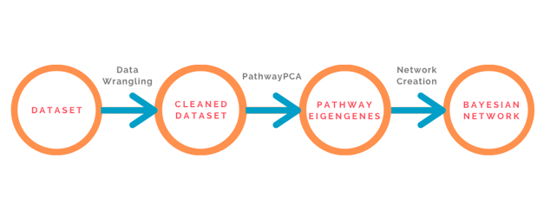

Figure 2: Overview of Methodology

**DATASET**

The REMBRANT dataset was selected for this capstone. REMBRANDT stands for Repository for Molecular Brain Neoplasia Data.[16] It was a joint initiative between the National Cancer Institute and the National Institute of Neurological Disorders and Stokes in which they collected brain cancer data from various universities and institutes.[16] The goal was to provide researchers with a dataset that was robust and large since brain cancer data is limited.[16] Of the 542 samples, only the low-grade Glioblastoma samples and the controls were used. This was because only early onset Glioblastoma was of interest, not late stage glioblastoma.

**DATA WRANGLING**

The first step in preparing the dataset was to download the Affymetrix Gene Key. The Gene Chip used to collect this data was the Affymetrix HG-U133 Plus 2 Gene Chip. Since the Affymetrix IDs correspond to a HUGO Gene Symbol, the IDs were replaced with the correct gene symbol.[17] After the genes were labeled, any hypothetical genes and nonspecific binding sites were removed. This is because the Affymetrix gene chip contains binding sites that were non-specific. The data was then split into 80-20 training and test set and scaled appropriately.

**EIGENGENE CREATION**

One issue that arises when using biological data is that biological processes in the cell are not modeled by just one gene. Biological processes are a combination of not only genes, but interactions between genes. Therefore, by using solely genes to create a model, there is a loss in biological information. In recent years, research has been done to avoid this loss of biological information via Network and Pathway Analysis.[18]

It is well known that one gene can be a part of multiple different biological processes. By forcing a model to only have genetic expression information, a significant loss of biological information occurs. As a result, many packages have been developed in order to reduce dimensionality of the data set while also preserving as much biological information as possible.

**PATHWAYPCA**

The package used for this capstone project was a package called PathwayPCA. This package performs Principal Component Analysis (PCA) in order to reduce the dimensionality of the data while also retaining as much biological information as possible by using pathway analysis.

Pathway analysis is an important step in this process, therefore, the first step in performing PathwayPCA is the downloading of a collection of pathways.[15] The C2 Canonical pathways collection was downloaded from Molecular Signatures Database (MSigDB).[19] The C2 Canonical pathway collection is a collection of various different biological pathways in the body. These pathways range from metabolic pathways to cell cycle pathways.[19] Each pathway contains a set of genes that canonically represent a biological process.[19] These gene sets are compiled by domain experts.

Once the pathway collection was obtained, the next step in the process was to perform PCA using these pathways.[15] To do this, the data is first subsetted to only include the genes in the gene set of a pathway.[15] Then PCA is performed to create the Eigengene that represents the pathway.[15] This process is then performed for all pathways in the collection.[15] However, unlike other packages, a gene is not forced to be a part of only one single Pathway Eigengene.[18] A gene can be a part of multiple different Pathway Eigengenes. This allows for the preservation of the fact that genes have multiple functions and are not part of only one pathway.

Once PCA is performed for each pathway, these pathway Eigengenes are then extracted and tested for biological relevance against the clinical response variable.[15] Pathway Eigengenes that are found to be relevant have low p values and pathway Eigengenes found to be irrelevant have high p values.[15] Lastly, once the Pathway Eigengenes have been tested for relevance, a dataset was created using the top 100 relevant pathways.

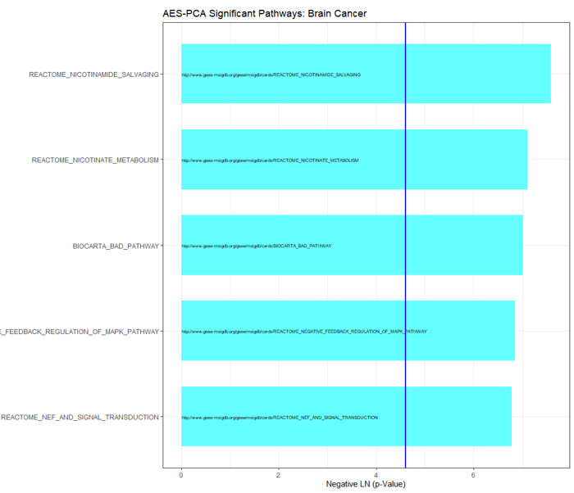

Figure 3: Negative LN P value plotted vs Pathway. Any pathway above the line is significant while any pathway below the line is not significant

**NETWORK CREATION**

In order to explore the relationship between Glioblastoma and the biological pathways, a Bayesian Network was created. Bayesian networks are a directed acyclic graph (DAG) that defines the nodes as the random variable and the edge as the relationship between the variables.[18] These edges model the casual interaction between the random variables.[18] In order to create the network, the Hill Climbing algorithm from the BNLearn Package was used.[20]

The Hill Climbing Algorithm attempts to create the best possible network by performing every possible edge addition, reversal, and removal.[20] It then selects the process that increased the overall score of the network.[20] It repeats this for all nodes until it finds the best possible network for the data.[20]

CHAPTER 4: RESULTS

**PERFORMANCE EVALUATION**

In order to test the performance of the process, a 10-Fold Cross Validation was performed using prediction error as the measurement. In addition, the Bayesian Network was compared to other popular algorithms. The Bayesian Network had a predictive accuracy of 78% and was non-inferior in its predictive accuracy when compared to other algorithms.

|  |  |  |
| --- | --- | --- |
| **10 – Fold Cross Validation (Pathway Approach)** | | |
|  | **Average Accuracy** | **Standard Deviation** |
| Bayesian Network | 78% | 3.6% |
| Classical Naïve Bayes | 73% | 8.4% |
| K-Nearest Neighbor | 78% | 3.6% |
| Support Vector Machine | 78% | 3.6% |
| Random Forest | 78% | 5.9% |
| Artificial Neural Network | 68% | 7.1% |

Table 1: 10-Fold Cross Validation Results

After performing the 10-Fold Cross Validation on the Pathway Approach, it was then compared to a 10-Fold Cross Validation using the top 100 correlation genes. It can be seen that the pathway approach for most models has an overall increase in the predictive accuracy. Only the Artificial Neural Network had a better predictive accuracy when created solely using the gene-based approach.

|  |  |  |  |  |
| --- | --- | --- | --- | --- |
| **10-Fold Cross Validation (Pathway Approach vs Gene Approach)** | | | | |
| **Algorithms** | **Average Accuracy (Pathway)** | **Standard Deviation (Pathway)** | **Average Accuracy**  **(Gene)** | **Standard Deviation (Gene)** |
| Bayesian Network | 78% | 3.6% | 73% | 3.7% |
| Classical Naïve Bayes | 73% | 8.4% | 74% | 12.8% |
| K-Nearest Neighbor | 78% | 3.6% | 76% | 7.1% |
| Support Vector Machine | 78% | 3.6% | 74% | 8.0% |
| Random Forrest | 78% | 5.9% | 75% | 8.5% |
| Artificial Neural Network | 68% | 7.1% | 74% | 11.2% |

Table 2: Pathway Approach vs Gene Approach

Lastly, each model was tested using the 20% testing set that was set aside. From the results, it can be seen that the Bayesian network was non-inferior to the other algorithms in terms of accurately predicting Glioblastoma.

|  |  |
| --- | --- |
| **Testing Set Results** | |
| **Algorithms** | **Accuracy (Pathway)** |
| Hill Climbing Bayesian Network | 80% |
| Classical Naïve Bayes | 82% |
| K-Nearest Neighbor | 80% |
| Support Vector Machine | 78% |
| Random Forest | 78% |
| Artificial Neural Network | 68% |

Table 3: Test Set Results

**ANALYZING THE NETWORK**

One unique advantage of using a Bayesian Network is that the relationship between pathways and Glioblastoma can be easily explored and evaluated for biological relevance. Bayesian networks are commonly used in the field of genomics to help model and discover new relationships. During the 10-Fold Validation, an exploratory analysis was performed to see how often certain pathways were appearing in the networks. From the analysis, it was noticed that 16 pathways appeared 100% of the time, 16 pathways appeared 90% of the time, 18 pathways appeared 80% of the time, and 206 pathways appeared 70% or less. Some of these pathways were selected and their association with glioblastoma was investigated.

|  |  |  |
| --- | --- | --- |
| **Repeating Pathways in the 10-Fold Cross Validation** | | |
| **Pathway** | **Percentage** | **Association with Glioblastoma** |
| Prion Pathway | 100% | Prions contribute to the tumorigenesis of Glioblastoma.[21] |
| Cell Programmed Death | 100% | Deregulation of this pathway allows for Glioblastoma cells to grow unchecked.[22] |
| MAPK Pathway | 100% | Hyperactivation of this pathway allows for tumorigenic progressions.[23] |
| Ceramide Pathway | 100% | Deregulation of this pathway allows for Glioblastoma cells to grow unchecked and not undergo cell death.[24] |
| PLC-epsilon pathway | 80% | Deregulation promotes Tumorigenesis and is a known to contain oncogenes for many types of cancer.[25][26][27] |

Table 4: Pathway Frequency in the 10-Fold Validation and their association with Glioblastoma

Lastly, in order to fully explore the casual relationship between Glioblastoma and the different pathways, two final networks were created using the full dataset. In the pathway-based approach network, it was decided that Glioblastoma interacts with only one pathway, while the gene-based approach decided that Glioblastoma interacts with five different genes. The biological relevance of each pathway and gene was assessed. The PLC-epsilon pathway is known to promote Tumorigenesis and contains oncogenes for many types of cancers, in addition to Glioblastoma.[25][26][27] However, when performing a literature search on the genes selected to be interacting with Glioblastoma, only three out of the five genes were found to be loosely associated with Glioblastoma. Therefore, it is always important to verify the biological relevance of a model to ensure accuracy and clinical relevance.

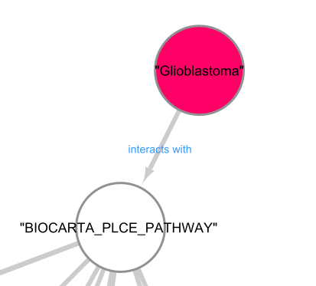

Figure 4: Zoomed in picture of the Glioblastoma Node in the Pathway Bayesian Network.

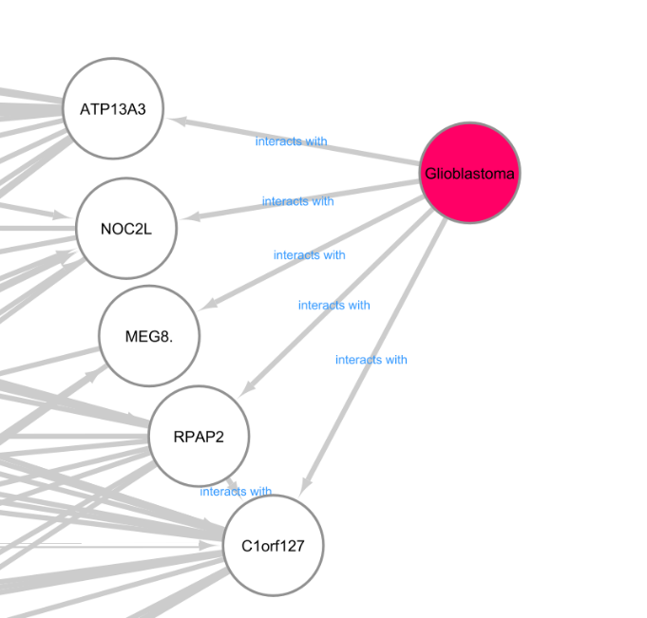

Figure 5: Zoomed in picture of the Glioblastoma Node in the Gene Bayesian Network.

|  |  |
| --- | --- |
| **Literature Analysis of Nodes Directly Interacting with Glioblastoma** | |
| **Pathways/Genes** | **Association with Glioblastoma** |
| PLC-epsilon pathway | Deregulation promotes Tumorigenesis and is a known to contain oncogenes for many types of cancer.[25][26][27] |
| ATP13A3 | Is abnormally expressed in Glioblastoma patients but its role is unclear.[28] |
| MEG8 | Plays a role in lung and pancreatic cancer.[29] |
| NOC2L | Theorized to be associated with glioblastoma.[30] |
| C1orf127 | No papers documenting its role in Glioblastoma or cancer. |
| RPAP2 | No papers documenting its role in Glioblastoma or cancer. |

Table 5: Literature Analysis of Nodes that directly interact with Glioblastoma. The association with Glioblastoma is listed for every node.

CHAPTER 5: DISCUSSION

**SIGNIFICANCE OF PATHWAY ANALYSIS**

Biological processes in the cell require the coordination of multiple genes and are not the result of a single gene. As a result, network and pathway analysis has been developed in order to detect and model these relationships. Because of this, a network and pathway-based approach has advantages over the conventional approach of using solely gene expression.[15][18] Biological information can be gained while also providing a biological direction to the models.[15][18] Conventional gene-based approach has the tendency to introduce noise and error into models. Important genes can be missed and not included while genes irrelevant to the clinical response may be included and given high significance in the model.

As can be seen by the literature analysis of the Pathway model and the Gene-based model, the undirected Gene-based model created network connections that did not make sense biologically. When putting statistical models to use in the clinical field, it is important to keep in consideration the Principal of Parsimony, the idea that a simple explanation is better than a complicated one.[32] When doctors are trying to monitor and determine if a patient has Glioblastoma, it is much more cost and time effective to monitor a single pathway then to monitor a multitude of different genes. Therefore, models created with biological relevance as their defining feature will prove to be more effective at helping clinicians than models that have little to no biological direction to them.

**ANALYSIS OF MODELS**

When analyzing the models created, it was shown that by using a pathway-based approach, the accuracy of the predictions went up for most algorithms. In addition, it was shown that using a Bayesian Network provided non-inferior results. The advantages of using a Bayesian Network compared to other models is that Bayesian Networks model causal relationships; relationships between the different pathways can be analyzed. This provides more information to doctors and clinicians than a simple classification model would. Since cancers, especially Glioblastoma, have effects that are not localized to just one location, it is of clinical importance to be able to monitor the relationships and effects between pathways. Due to the severity of Glioblastoma, this increase in information via Pathway Analysis and Causal Relationships may help in providing better treatments to patients and potentially increase the 5-year survival rate.

CHAPTER 6: CONCLUSION

Glioblastoma is a very deadly type of brain cancer that does not have a good survival prognosis. Current treatments have many risks involved and the 5-year survival rate is low.[5] As a result, new ways to detect and understand low grade Glioblastoma are being researched. In this capstone project, I provided a methodology to create predictive models with good prediction accuracy and contain biological direction. The Bayesian Network approach proved to be advantageous because it can be used to delineate pathways that are associated with Glioblastoma, unlike the other algorithms that function more as a classifier. If combined with the new emerging research in blood work detection, this method could potentially create a non-invasive way to detect Glioblastoma and other cancers earlier than traditional diagnosis methods.[13][14]

REFERENCES

1. Quick Brain Tumor Facts. (2020, April 08). Retrieved June 24, 2020, from https://braintumor.org/brain-tumor-information/brain-tumor-facts/
2. Watson, S. (2018, September 23). Glioblastoma: Survival Rates, Treatments, and Causes. Retrieved from https://www.healthline.com/health/brain-tumor/glioblastoma
3. Cancer. (2019, December 03). Retrieved December 03, 2020, from https://stanfordhealthcare.org/medical-conditions/cancer/cancer.html
4. Sofroniew, M., &amp; Vinters, H. (2010, January). Astrocytes: Biology and pathology. Retrieved December 03, 2020, from <https://www.ncbi.nlm.nih.gov/pmc/articles/PMC2799634/>
5. Bi, W. L., & Beroukhim, R. (2014, September). Beating the odds: extreme long-term survival with glioblastoma. Retrieved from <https://www.ncbi.nlm.nih.gov/pmc/articles/PMC4136904/>
6. Glioma. (2020, April 04). Retrieved December 03, 2020, from <https://www.mayoclinic.org/diseases-conditions/glioma/symptoms-causes/syc-20350251>
7. Ostrom, Q., Gittleman, H., Farah, P., Ondracek, A., Chen, Y., Wolinsky, Y., . . . Barnholtz-Sloan, J. (2013, November). CBTRUS statistical report: Primary brain and central nervous system tumors diagnosed in the United States in 2006-2010. Retrieved December 03, 2020, from <https://www.ncbi.nlm.nih.gov/pmc/articles/PMC3798196/>
8. Risk Factors for Brain and Spinal Cord Tumors. (n.d.). Retrieved December 03, 2020, from <https://www.cancer.org/cancer/brain-spinal-cord-tumors-adults/causes-risks-prevention/risk-factors.html>
9. Glioma. (2020, April 04). Retrieved December 03, 2020, from <https://www.mayoclinic.org/diseases-conditions/glioma/diagnosis-treatment/drc-20350255>
10. Cancer, C. (n.d.). Temozolomide. Retrieved December 03, 2020, from http://chemocare.com/chemotherapy/drug-info/Temozolomide.aspx
11. Hunter, P. (2017, November). The fourth pillar: Despite some setbacks in the clinic, immunotherapy has made notable progress toward becoming an additional therapeutic option against cancer. Retrieved December 03, 2020, from <https://www.ncbi.nlm.nih.gov/pmc/articles/PMC5666595/>
12. Magnetic Resonance Imaging (MRI). (n.d.). Retrieved December 03, 2020, from https://www.nibib.nih.gov/science-education/science-topics/magnetic-resonance-imaging-mri
13. Muralidharan, K., Yekula, A., Small, J., Rosh, Z., Kang, K., Wang, L., . . . Carter, B. (2020, October 13). TERT Promoter Mutation Analysis for Blood-Based Diagnosis and Monitoring of Gliomas. Retrieved December 03, 2020, from <https://clincancerres.aacrjournals.org/content/early/2020/11/25/1078-0432.CCR-20-3083>
14. Bagley, S., Nabavizadeh, S., Mays, J., Till, J., Ware, J., Levy, S., . . . Carpenter, E. (2020, January 15). Clinical Utility of Plasma Cell-Free DNA in Adult Patients with Newly Diagnosed Glioblastoma: A Pilot Prospective Study. Retrieved December 03, 2020, from <https://clincancerres.aacrjournals.org/content/26/2/397>
15. Odom, G., Ban, Y., Colaprico, A., Liu, L., Silva, T., Sun, X., . . . Chen, X. (2020, July 02). PathwayPCA: An R/Bioconductor Package for Pathway Based Integrative Analysis of Multi‐Omics Data. Retrieved July 22, 2020, from <https://onlinelibrary.wiley.com/doi/abs/10.1002/pmic.201900409>
16. Gusev, Y., Bhuvaneshwar, K., Song, L., Zenklusen, J., Fine, H., &amp; Madhavan, S. (2018, August 14). The REMBRANDT study, a large collection of genomic data from brain cancer patients. Retrieved December 03, 2020, from <https://www.nature.com/articles/sdata2018158>
17. Braschi B, Denny P, Gray K, Jones T, Seal R, Tweedie S, Yates B, Bruford E. Genenames.org: the HGNC and VGNC resources in 2019. Nucleic Acids Res. 2019 Jan 8;47(D1):D786-D792. PMID:30304474
18. Agrahari, R., Foroushani, A., Docking, T., Chang, L., Duns, G., Hudoba, M., . . . Zare, H. (2018, May 03). Applications of Bayesian network models in predicting types of hematological malignancies. Retrieved December 03, 2020, from <https://www.nature.com/articles/s41598-018-24758-5>
19. Subramanian, A., Tamayo, P., Mootha, V., Mukherjee, S., Ebert, B., Gillette, M., . . . Mesirov, J. (2005, October 25). Gene set enrichment analysis: A knowledge-based approach for interpreting genome-wide expression profiles. Retrieved November 25, 2020, from <https://www.pnas.org/content/102/43/15545.abstract>
20. Marco Scutari (2010). Learning Bayesian Networks with the bnlearn R Package. Journal of Statistical Software, 35(3), 1-22. URL <http://www.jstatsoft.org/v35/i03/>
21. Ryskalin, L., Busceti, C. L., Biagioni, F., Limanaqi, F., Familiari, P., Frati, A., & Fornai, F. (2019). Prion Protein in Glioblastoma Multiforme. *International journal of molecular sciences*, *20*(20), 5107. <https://doi.org/10.3390/ijms20205107>
22. Fulda, S. Cell death-based treatment of glioblastoma. *Cell Death Dis* **9,** 121 (2018). <https://doi.org/10.1038/s41419-017-0021-8>
23. Krishna, K., Dubey, S., Singhvi, G., Gupta, G., & Kesharwani, P. (2020, September 10). MAPK pathway: Potential role in glioblastoma multiforme. Retrieved October 28, 2020, from <https://www.sciencedirect.com/science/article/pii/S221475192030462X>
24. Tea, M., Poonnoose, S., &amp; Pitson, S. (2020, January 1). Targeting the Sphingolipid System as a Therapeutic Direction for Glioblastoma. Retrieved December 03, 2020, from https://www.ncbi.nlm.nih.gov/pmc/articles/PMC7017054/
25. Dusaban, S., Purcell, N., Rockenstein, E., Masliah, E., Cho, M., Smrcka, A., & Brown, J. (2013, February 26). Phospholipase Cɛ links G protein-coupled receptor activation to inflammatory astrocytic responses. Retrieved November 23, 2020, from <https://www.pnas.org/content/110/9/3609>
26. Yun S; Byun HY; Oh YS; Yang YR; Ryu SH; Suh PG;. (n.d.). Protein kinase C-alpha negatively regulates EGF-induced PLC-epsilon activity through direct phosphorylation. Retrieved November 23, 2020, from <https://pubmed.ncbi.nlm.nih.gov/19948183/>
27. Tyutyunnykova, A., Dubrovska, A., & Telegeev, G. (2017). The controversial role of phospholipase C epsilon (PLCε) in cancer development and progression. Retrieved November 23, 2020, from <https://www.jcancer.org/v08p0716.htm>
28. Xiong, J., Bing, Z., Su, Y., Deng, D., & Peng, X. (2014, May 28). An integrated mRNA and microRNA expression signature for glioblastoma multiforme prognosis. Retrieved November 23, 2020, from <https://www.ncbi.nlm.nih.gov/pmc/articles/PMC4037214/>
29. Terashima, M., Ishimura, A., Wanna-Udom, S., & Suzuki, T. (2018, November 23). *MEG8* long noncoding RNA contributes to epigenetic progression of the epithelial-mesenchymal transition of lung and pancreatic cancer cells. Retrieved November 23, 2020, from <https://www.ncbi.nlm.nih.gov/pmc/articles/PMC6254362/>
30. Lab, M. (2005). Interaction Summary. Retrieved November 23, 2020, from <https://thebiogrid.org/interaction/720110>
31. File:Astrocyte5.jpg. (2020, May 20). *Wikimedia Commons, the free media repository*. Retrieved 19:52, December 3, 2020 from <https://commons.wikimedia.org/w/index.php?title=File:Astrocyte5.jpg&oldid=420517559>.
32. Carr, D. (2002). Principles of Parsimony Analysis: An example with molecular data. Retrieved December 04, 2020, from https://www.mun.ca/biology/scarr/2900_Parsimony_Analysis.htm